

Edrington

D.A.I.P Project:

Optimal Selection

of Suppliers

Group 4

Samuel Bennie

Adel Shaman

Yash Sharma

Pin-you Lin


Yu Hong Wong

Lingyu Sun

Ruixian Zhao

CONTENT

1. Executive Summary ------------------------------------------------------------------------------------------ 1

2. Introduction ----------------------------------------------------------------------------------------------------- 1

3. Methodology --------------------------------------------------------------------------------------------------- 2

3.1 Data Pre-Processing------------------------------------------------------------------------------------ 2

3.2 Optimisation model ------------------------------------------------------------------------------------- 3

Model Input Selection ---------------------------------------------------------------------------------- 3

Objective Function, Constraints & Boundaries -------------------------------------------------- 5

Three Different Cases of Running ‘Linprog’ Function ------------------------------------------ 5

Purchase Priority of Vendors ------------------------------------------------------------------------- 5

4. Recommendations -------------------------------------------------------------------------------------------- 6

5. Conclusion ------------------------------------------------------------------------------------------------------ 6

1. EXECUTIVE SUMMARY

This study, commissioned by Edrington, works through building a model for optimal supplier selection. As per the client’s requirement, the data was cleansed, restructured and analysed using Python. After critical study of each constraint, the model notably relies on the cullet percentage, lead time and vendor rating. Based on these factors, an algorithm is written to execute the model. The values of these constraints are imputable, and the algorithm produces the most optimal supplier selection for the given products at minimal cost.

2. INTRODUCTION

Edrington makes some of the world’s best-loved Scotch whiskies, including The Macallan, The Famous Grouse, Highland Park and The Glenrothes. The company also aspires to be the leading spirit supply chain. The current case presented focus solely on optimizing its supply chain selection. Supply chain selection is one of the key decisions that play a major role in a company's long-term credibility. The basic idea is to have a supplier or an optimal combination of suppliers/supplies at minimum cost while upholding the best quality of the material received. The client, Edrington, would like to implement the same to their supply chain. As a result, with the given data an optimal

1

model has been developed to suit the client’s requirements which can be implemented in a real time scenario.

An excel was provided by the client consisting of various qualitative and quantitative parameters of four suppliers and approximately a hundred of products. The monthly demand of the client, supplier’s capability, maximum deliverable time of product, etc. are included in the data. A model has been proposed using some key parameter that will simplify the supplier selection process for the client’s procurement team. The model construction was driven by the company’s vision while bearing the immediate goal of being cost effective.

3. METHODLOGY

The objective of this model is to gain shrewdness in the selection of the optimal sequence of suppliers per month at the least cost with the tremendous achievable quality based on the prior quantitative guidelines and constraints. During the execution, some assumptions and scenarios are added in this model.

The preliminary analysis plan and report outline were inspired by analytical objectives which intended to minimize expenses was established at the start of the project. A linear programming model with the goal of minimizing costs was to be built. This involved excluding parameters or constraints which were not suitable for architecting this model post the data pre-processing phase.

3.1 DATA PRE-PROCESSING

The main aim of pre-processing the data is to enhance the analytical processes on

be conducted on it. Data-cleansing forms an integral part of this process. There are the few main guidelines that are followed.

- Checking the missing and null value, manually change the wrong input or incompatible values if they are known. For example, for Company 4 and Flint color leave the second price.

- Get rid of the strings in lead time and transfer them into floating variables so that can be used in the following model.

2
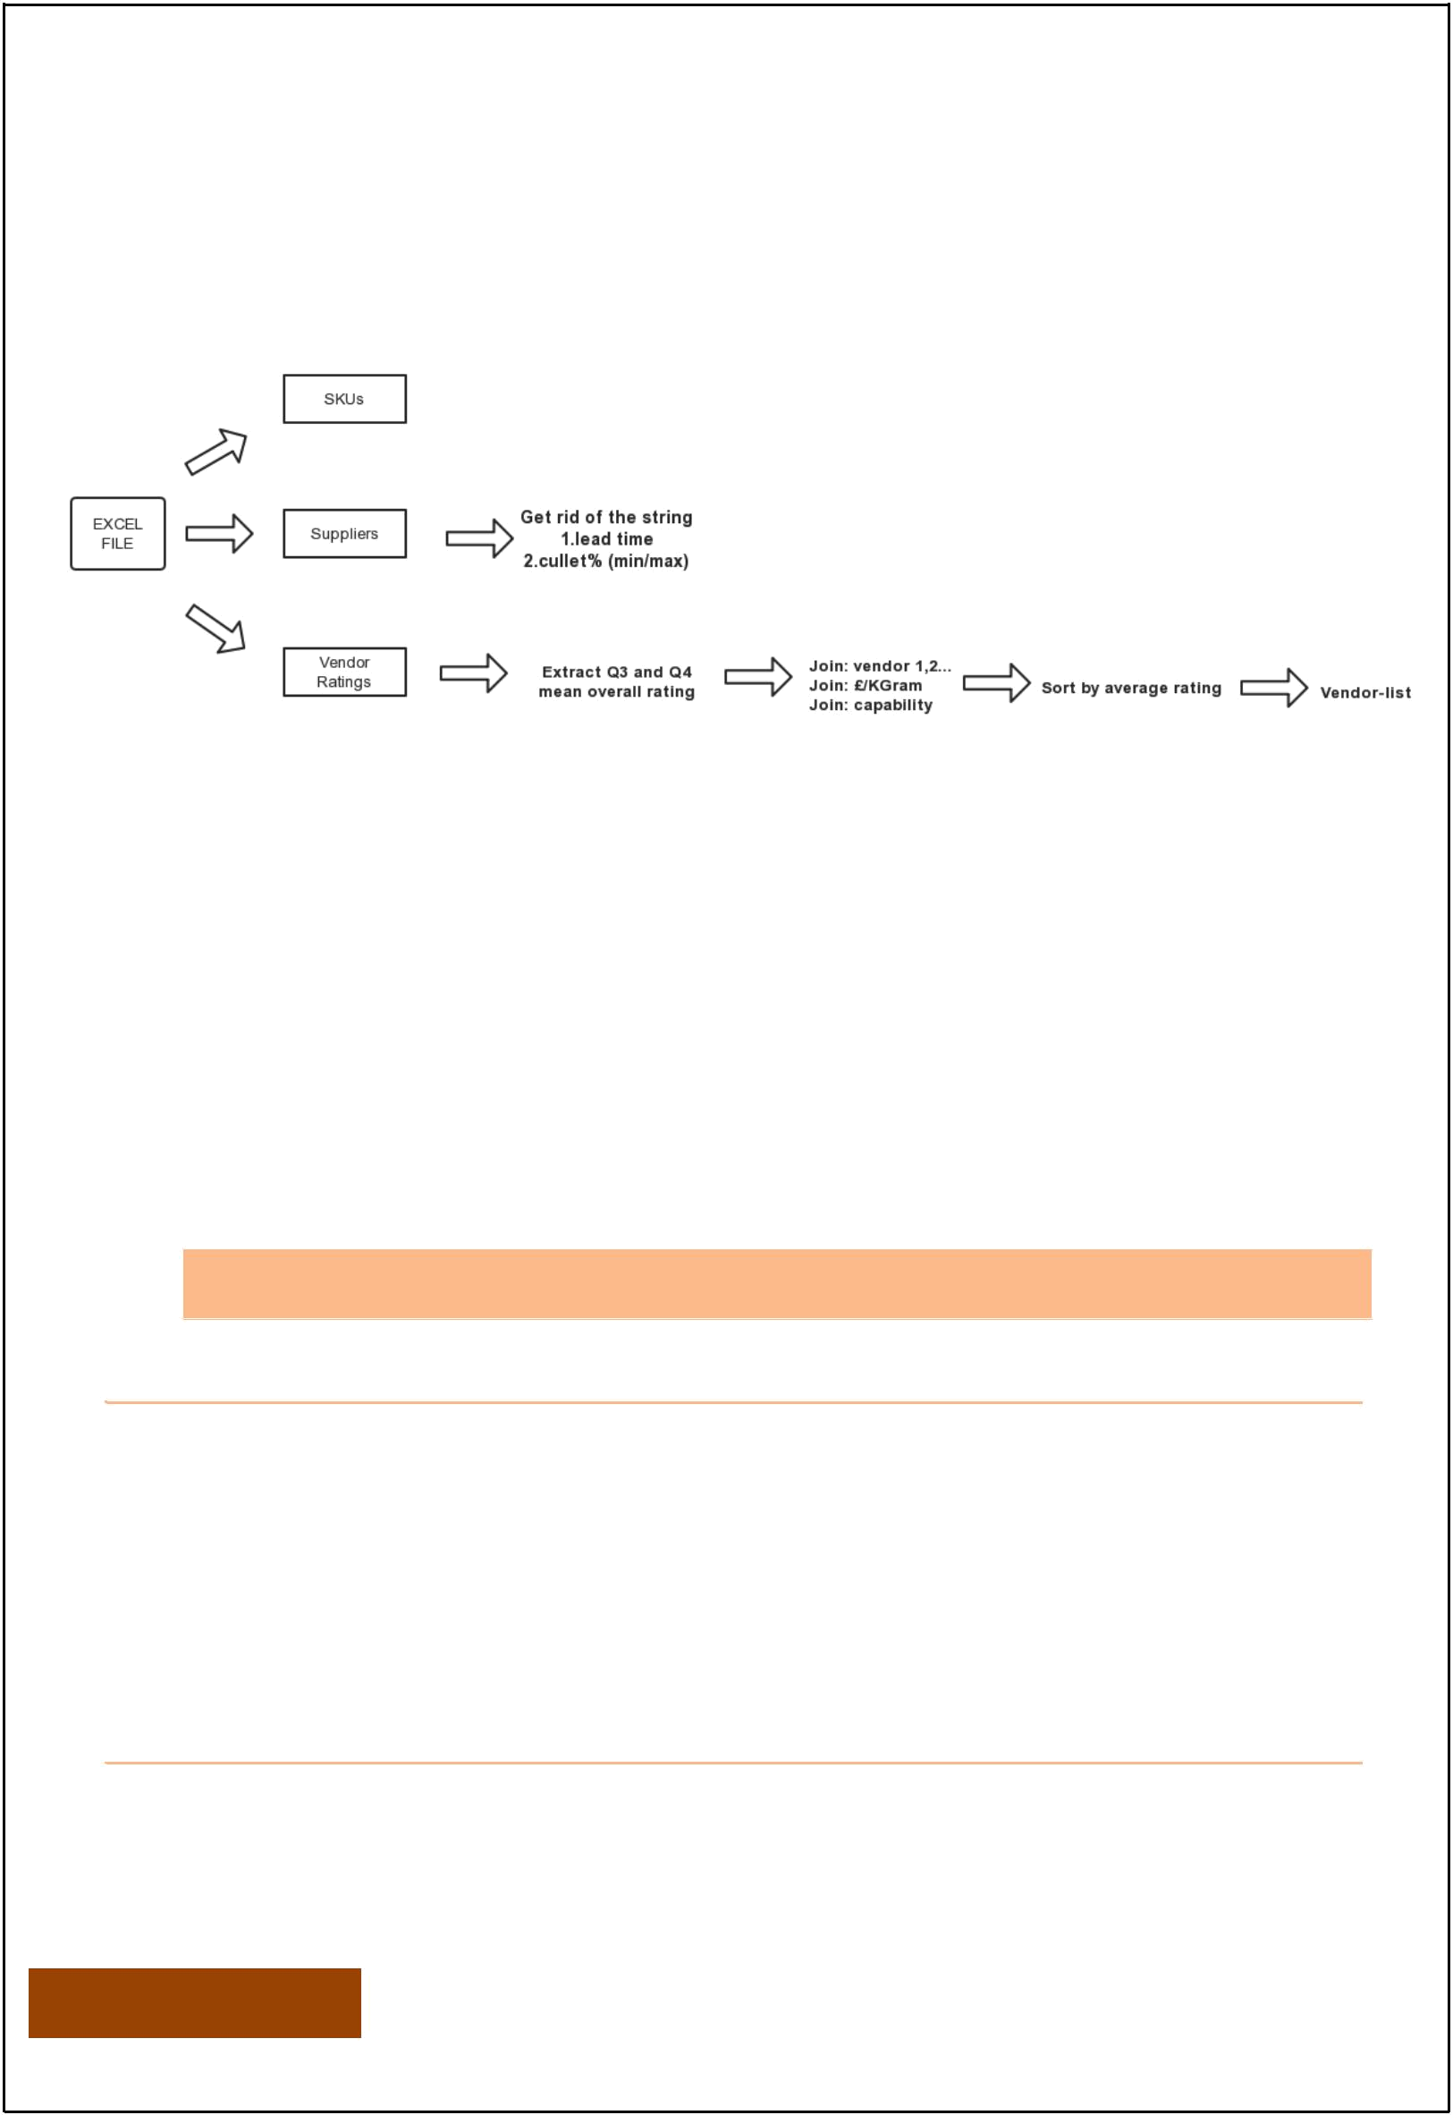
- Extract the 2 quarters mean overall rating of the four suppliers, this will be used in the optimize model to break the tie circumstance.

Once the above steps are completed the data is fed into the model. A more detailed workflow of preprocessing data is shown in Figure 1.

Figure 1 Preprocessing the data from the sheets

A semi-automated model was developed using Python’s ‘linprog’ library from
the ‘scipy.optimize’ package. Lead time, cullet and the capability of suppliers were considered as constraints. Maximum lead time and the range of cullet percentage are used defined. These parameters would be utilized in the model which filter out unsuitable data. The program outputs the results of different combinations as CSV files which can be used by the procurement team. If these values are not defined by the user, then the program will assume a set of default values as the threshold (10 weeks of lead time and no limits in the cullet percentage).

3.2 OPTIMISATION MODEL

The model architecture was don using a recurring ‘FOR-LOOP’.

LEAD TIME & CULLET% SCENARIO ANALYSIS

Before putting all the existing data into the model, the user has to define the lead time and the range of cullet percentage. By changing these parameters, the company could run scenario analysis which could stimulate the real world as it is reasonable for company to have tolerance on lead time or on cullet percentage. However, if the user does not input anything, their default setting would be 10 weeks lead time, 0% to 100% cullet%.

MODEL INPUT SELECTION

Selection process is carried out in three steps. Each step is based on the results of the previous step. The first aspect to be considered is to meet the product demands of

3
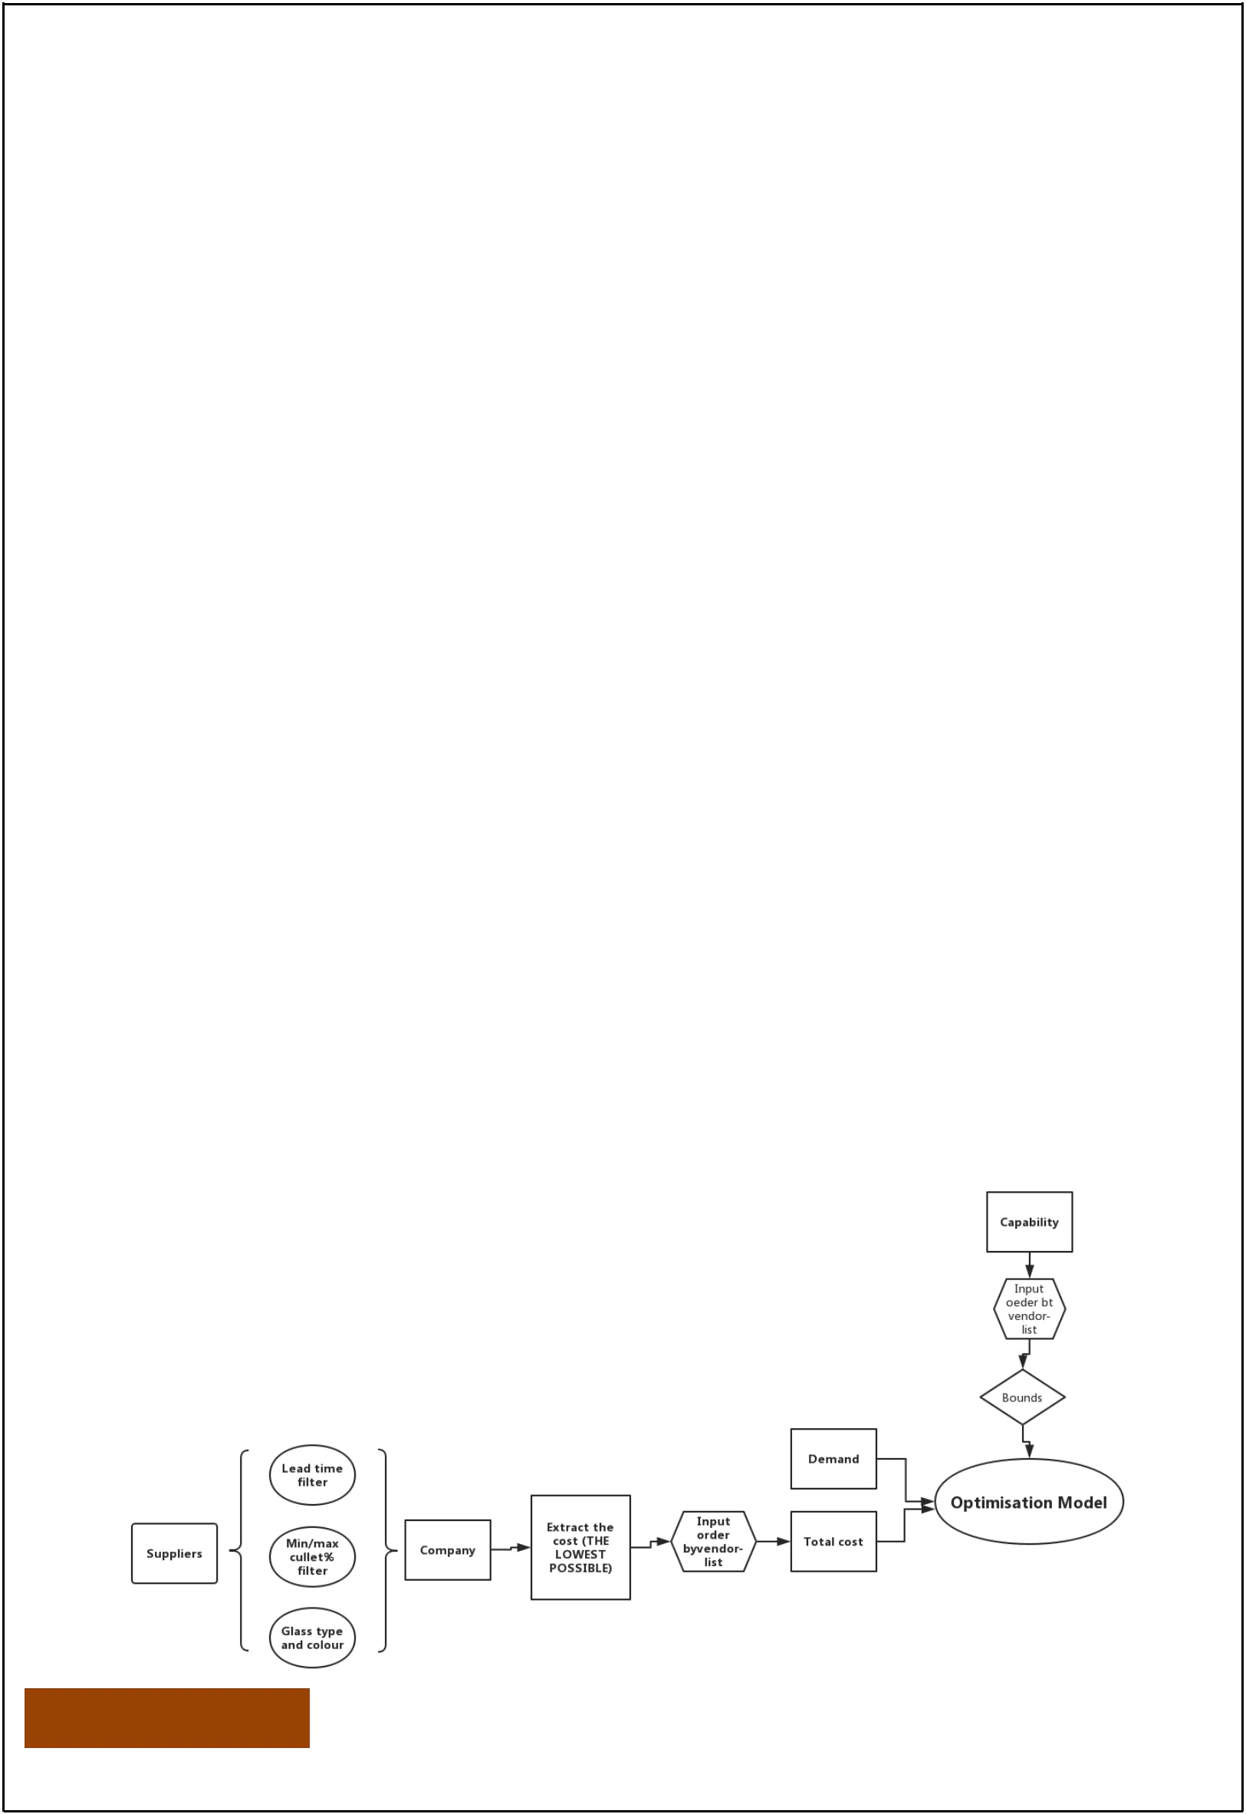
Edrington. Hence, the monthly demand in terms of bottles is read into Python bottles. This is imported into Python’s np.ceil () function which returns the ceiling of the input. For example, if the monthly demand is 378233.333333333, the function will return 378234. After this, the capability of each company will be extracted from the Excel sheet. The number of bottles a supplier can provide should be rounded down to the nearest integer as opposed to a decimal value as a decimal would be considered as a work-in-progress. Therefore, the int () function is used. For example, if the capability of a supplier is 24488.1, the value is adjusted to 24488, on the other hand, if it’s 24488.9, it will also be adjusted as 24488. This will ensure that the suppliers will adequately meet the needs of Edrington.

Step 1: Here we narrow the scope of suppliers, in other words, to meet the restrictions. For instance, only when the data reaches the client’s maximum acceptable lead time will be left, and this method applied to the percentage of cullet.

Step 2: In this stage, we use the data selected from the previous step to read the colour and the glass type of the bottles.

Step 3: The third step is to extract the lowest price of each product from respective company

In case of non-available supply from a vendor: In this situation, the capability of a supplier would therefore be changed to 0 so that the function in the loop could still be functionable and generate a list of errorless solution.

After these steps, we get the results of the lowest price of a product from each supplier under the user-specified circumstances and enter the next stage of this model. The workflow of detail of these steps are Shown in figure 2.

Figure 2 The workflow of the overall model selection

4
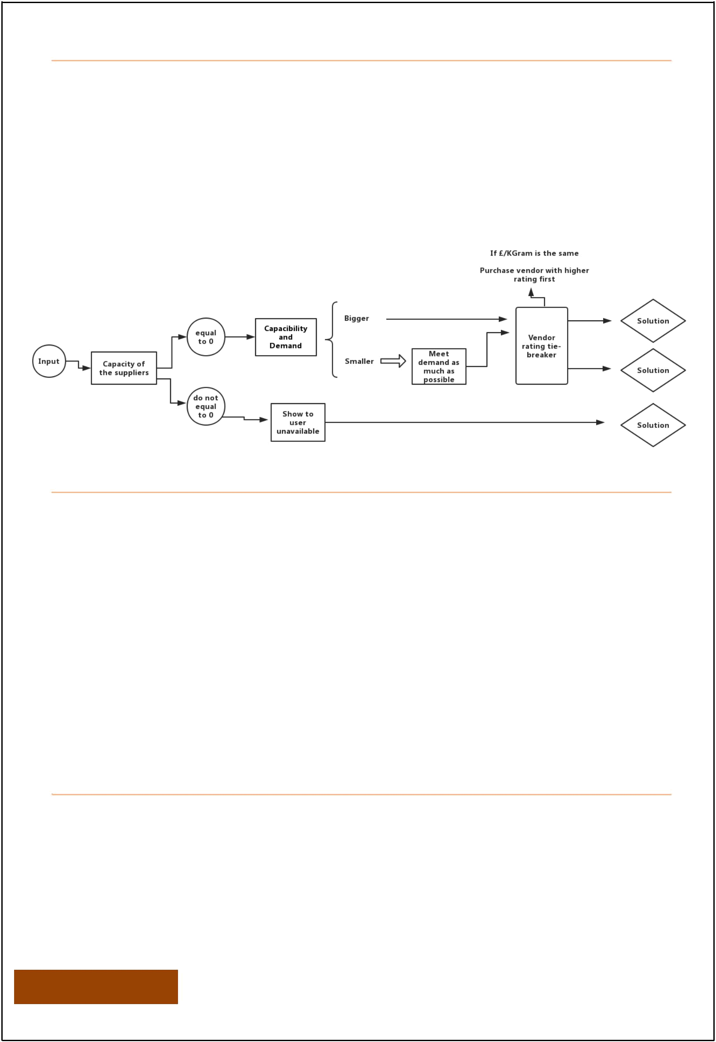
OBJECTIVE FUNCTION, CONSTRAINTS & BOUNDARIES

As the objective is to minimise the cost, the objective function would be the total cost of each product, which is the summation of the cost per kilogram multiplied by

the quantity ordered from each supplier. There is only one constraint in this model, which is the total order from the suppliers equals to the monthly demand of that product’s glass. As for boundaries, they are between zero to each supplier’s capability. The Figure 3 illustrates how the objective function works.

Figure 3 The Objective Model Decision Tree

THREE DIFFERENT CASES OF RUNNING ‘LINPROG’ FUNCTION

Given the various scenarios defined by users, there are three case which are highly possible.

Case1: The suppliers together have sufficient supply for the demand. In this case, the linprog function would run normally.

Case2: The second one would be that the vendors together have limited availability. The model would still run for the optimal solution and satisfy the demand as much as possible by changing the monthly demand to the summation of all the supplies.

Case3: The third one is that there is no available supplier and the model would show a message indicate this situation without running the linprog function

PURCHASE PRIORITY OF VENDORS

Although having the same price from different vendors is not in this dataset, it is still possible in the future expansion of this product or vendor list. In an event of same price, the model is programmed to give the priority to the vendor who has higher two quarters average overall score. Using this indicator could generalise the

5

overall performance of the vendor and their reliability on supply. Besides, it could potentially stimulate the vendors’ performance.

At the end of the loop, the result of each product would be appended to the several lists. The user can choose to save the solution list as CSV files.

4. RECOMMENDATIONS

The recommendations of 10 weeks lead time and 20%-40% cullet is in the appendix 2. From the list we can find the combinations of suppliers. For example, for the first type of glass we need, the program recommends that buy 11134 glasses from company 2 and 13016 glasses from company 3. There have some tricky recommendation combinations such as 2545 from company 2 and 50 from company 3. It is applicable for the procurement team to omit that small part and add them to the bigger one, if it can make life easier. Since there will not be over 5% of the cost floating by doing that. The different input by the user will get different results from the program.

5. CONCLUSION

As shown above, the model could handle different situation very well since it has programmed several scenario analysis and the different cases the model would probably encounter. Moreover, it has a convenient option that the result could be saved in csv file. For most of the time, the result and the solution list are generated in less than a second.

However, in reality, the price discrimination based on the order size could hinder the algorithm as the price would therefore vary accordingly. A discount could be given if order is larger enough. Besides, some qualitative criteria are not included in this model, such as the environmental effects of maybe some type of glass.

The ratings provided are limited to only two quarters which might make the purchase priority more likely to be biased since it has a relatively small sample. Also, the model is deliberately made semi-automatic due to data limitations. In case of cost minimisation, if cullet percentage is standardised by the client for all their products then not only will there be no compromise in the quality but also would incline to be more cost effective.

6

6
Appendix 1 The Code of the Model 02/13/19 03:05:52 Case 4.py

Page 7

- importpandasaspd
- importnumpyasnp
- fromscipy.optimizeimportlinprog

- ###read the excel file
- sku=pd.read_excel('DAIP glass data.xlsx',sheet_name='SKUs Data')
- suppliers=pd.read_excel('DAIP glass data.xlsx',sheet_name='Suppliers Data')
- ratings=pd.read_excel('DAIP glass data.xlsx',sheet_name='Vendor Ratings')

- ###Data cleanse

- #Get rid of the string in lead time
- suppliers=suppliers.sort_values(['Lead time '],ascending=True)
- lead=suppliers['Lead time ']
- suppliers=suppliers.drop(['Lead time '],axis=1)

- time=[]
- forninrange(0,len(lead)):
- no_weeks=lead[n].replace('weeks','')
- no_weeks=int(no_weeks)
- time.append(no_weeks)

- time=pd.DataFrame(time,columns=['Lead time'])
- suppliers=suppliers.join(time)

- #Vendor Mean Overall Ratings
- vendor_1=ratings.loc[ratings['Supplier']=='Company 1']
- vendor_1=np.array(vendor_1['Overal Rating'])
- vendor_1=np.mean(vendor_1)
- vendor_2=ratings.loc[ratings['Supplier']=='Company 2']
- vendor_2=np.array(vendor_2['Overal Rating'])
- vendor_2=np.mean(vendor_2)
- vendor_3=ratings.loc[ratings['Supplier']=='Company 3']
- vendor_3=np.array(vendor_3['Overal Rating'])
- vendor_3=np.mean(vendor_3)
- vendor_4=ratings.loc[ratings['Supplier']=='Company 4']
- vendor_4=np.array(vendor_4['Overal Rating'])
- vendor_4=np.mean(vendor_4)
- supplier_list=['Vendor 1','Vendor 2','Vendor 3','Vendor 4']
- supplier_list=pd.DataFrame(supplier_list,columns=['Vendors'])
- vendor_list=[vendor_1,vendor_2,vendor_3,vendor_4]
- vendor_list=pd.DataFrame(vendor_list,columns=['Ratings'])
- vendor_list=vendor_list.join(supplier_list)

- ###Lead time analysis input
- max_lead_time=input('Enter Maximum Lead Time Allowed(default: 10 weeks):')
- ifmax_lead_time=='':
- max_lead_time=10

- else:
- max_lead_time=float(max_lead_time)

- ###Cullet% analysis input
- min_cullet=input('Enter Minimum Cullet % Allowed(default: 0%) :')

- if min_cullet == '':

57 min_cullet=0

- else:
- min_cullet=float(min_cullet)
- max_cullet=input('Enter Maximum Cullet % Allowed(default: 100%) :')
- ifmax_cullet=='':
- max_cullet=1

- else:
- max_cullet=float(max_cullet)

- ###Prepare for the solution list
- solution=sku.loc[:,sku.columns[:6]]

- sup_num=[]

- final_cost=[]

- demand=[]

- deficit=[]

- #####For loops (Optimisation Model)
- foriinrange(0,len(sku.index)):
- #extract demand of the particular product
- demand_bottles=np.ceil((sku['Monthly Demand'][i]))
- #extract capability of each supplier on that product
- s1_cap=int(sku['Capability in bottles Supplier 1'][i])
- s2_cap=int(sku['Capability in bottles Supplier 2'][i])
- s3_cap=int(sku['Capability in bottles Supplier 3'][i])
- s4_cap=int(sku['Capability in bottles Supplier 4'][i])
- #convert gram to KG and extract glass and colour data
- weight_in_kg=(sku['Weight (g)'][i])/1000
- glass=sku['Glass Type'][i]
- colour=sku['Colour'][i]
- ###Selection of the product
- #Lead time filter
- step1=suppliers.loc[suppliers['Lead time']<=max_lead_time]
- #Cullet% filter
- step1b=step1.loc[suppliers['Cullet%']>=min_cullet]
- step1b1=step1b.loc[suppliers['Cullet%']<=max_cullet]
- #Glass type and colour filter
- step1c=step1b1.loc[suppliers['Glass Type']==glass]
- step2=step1c.loc[step1['Colour']==colour]
- #Product of respective suppliers
- step3_1=step2.loc[step2['Company']=='Company 1']
- step3_2=step2.loc[step2['Company']=='Company 2']
- step3_3=step2.loc[step2['Company']=='Company 3']
- step3_4=step2.loc[step2['Company']=='Company 4']
- #Extract the cost of each company's product
- costkg_1=(step3_1['£/KGram'])*weight_in_kg
- costkg_2=(step3_2['£/KGram'])*weight_in_kg
- costkg_3=(step3_3['£/KGram'])*weight_in_kg
- costkg_4=(step3_4['£/KGram'])*weight_in_kg
- ###check the suppliers' availability
- #Check if the suppliers could supply for the product
- len1=len(costkg_1)

- len2 = len(costkg_2)
116 len3 = len(costkg_3) Page 8
- len4=len(costkg_4)

- #Extract the lowest cost of each company's product
- costkg_1=costkg_1.min()
- costkg_2=costkg_2.min()
- costkg_3=costkg_3.min()
- costkg_4=costkg_4.min()
- #If they have no supply, then change the above variable to avoid error
- iflen1==0:
- s1_cap=0
- costkg_1=1
- iflen2==0:
- s2_cap=0
- costkg_2=1
- iflen3==0:
- s3_cap=0
- costkg_3=1
- iflen4==0:
- s4_cap=0
- costkg_4=1
- #Covert to float
- costkg_1=float(costkg_1)
- costkg_2=float(costkg_2)
- costkg_3=float(costkg_3)
- costkg_4=float(costkg_4)
- ###Create a list for tie-break
- ###by arranging the order of variable in
- ###objective function and the bounds
- #Join costkg into vendor list for variables order in objective function
- costkg_list=[costkg_1,costkg_2,costkg_3,costkg_4]
- costkg_list=pd.DataFrame(costkg_list,columns=['costkg'])
- vendor_list=vendor_list.join(costkg_list)
- #Join capability of each supplier for order in bounds
- cap_list=[s1_cap,s2_cap,s3_cap,s4_cap]
- cap_list=pd.DataFrame(cap_list,columns=['cap'])
- vendor_list=vendor_list.join(cap_list)
- #Sort by Vendor Ratings
- vendor_list=vendor_list.sort_values(['Ratings'],ascending=False)
- vendor_rank=vendor_list['Vendors']
- #define objective function
- total_cost=vendor_list['costkg']
- total_cost=np.array(total_cost)
- #define constraints' LHS anf RHS
- A_eq=[(1,1,1,1)]
- b_eq=[demand_bottles]
- #define boundaries

- s1_bounds = (0,s1_cap)
176 s2_bounds=(0,s2_cap) Page 9
- s3_bounds=(0,s3_cap)
- s4_bounds=(0,s4_cap)
- bounds=[0,0,0,0]
- bounds=pd.DataFrame(bounds,columns=['lower'])
- cap=vendor_list['cap']
- cap=np.array(cap)
- cap=pd.DataFrame(cap,columns=['cap'])
- bounds=bounds.join(cap)
- bounds=bounds.values
- ###3 different case of running linprog
- #If there is any aviliable supplier
- iflen1!=0orlen2!=0orlen3!=0orlen4!=0:
- #If they jointly have enough supply to meet the demand
- ifs1_cap+s2_cap+s3_cap+s4_cap>=demand_bottles:
- res=linprog(total_cost,A_eq=A_eq,b_eq=b_eq,bounds=bounds)
- print(sku['Material Code'][i])
- print(res)
- print("")
- num= res['x']
- cost=res['fun']
- deficit_i=[0]
- #If not
- else:
- b_eq=[s1_cap+s2_cap+s3_cap+s4_cap]
- res=linprog(total_cost,A_eq=A_eq,b_eq=b_eq,bounds=bounds)
- print(sku['Material Code'][i])
- print(res)
- print("")
- num= res['x']
- cost=res['fun']
- deficit_i=[demand_bottles-sum(num)]
- #If no available supplier
- else:
- print('No Supplier Available for:')
- print(sku['Material Code'][i])
- num=[0,0,0,0]
- cost=['No Supplier Available']
- deficit_i=[demand_bottles]
- #Append the result of each product into the lists
- demand.append(demand_bottles)
- sup_num.append(num)
- final_cost.append(cost)
- deficit.append(deficit_i)
- #Drop the column for next i in the loop
- vendor_list=vendor_list.drop(['costkg'],axis=1)
- vendor_list=vendor_list.drop(['cap'],axis=1)
- delbounds, cap, cap_list

- ###Generate a list of solution
- deficit=pd.DataFrame(deficit,columns=['Deficit'])
- solution=solution.join(deficit)
- sup_num=pd.DataFrame(sup_num,columns=vendor_rank)

- solution = solution.join(sup_num['Vendor 1'])
235 solution=solution.join(sup_num['Vendor 2']) Page 10

- solution=solution.join(sup_num['Vendor 3'])
- solution=solution.join(sup_num['Vendor 4'])
- final_cost=pd.DataFrame(final_cost,columns=['Optimal Cost'])
- solution=solution.join(final_cost)

- ###Option to save the result as csv
- csv_name=str(int(max_lead_time))+' weeks lead time solution.csv'
- save=input('Save to CSV? (Y/N)')
- ifsave=='Y'or'y':
- solution.to_csv(csv_name,index=False)
- print('done!')

Page 11

Appendix 2: The optimal solution for 10 weeks Lead Time and the cullt % bettween 0.2 to 0.4

10 weeks lead time solution
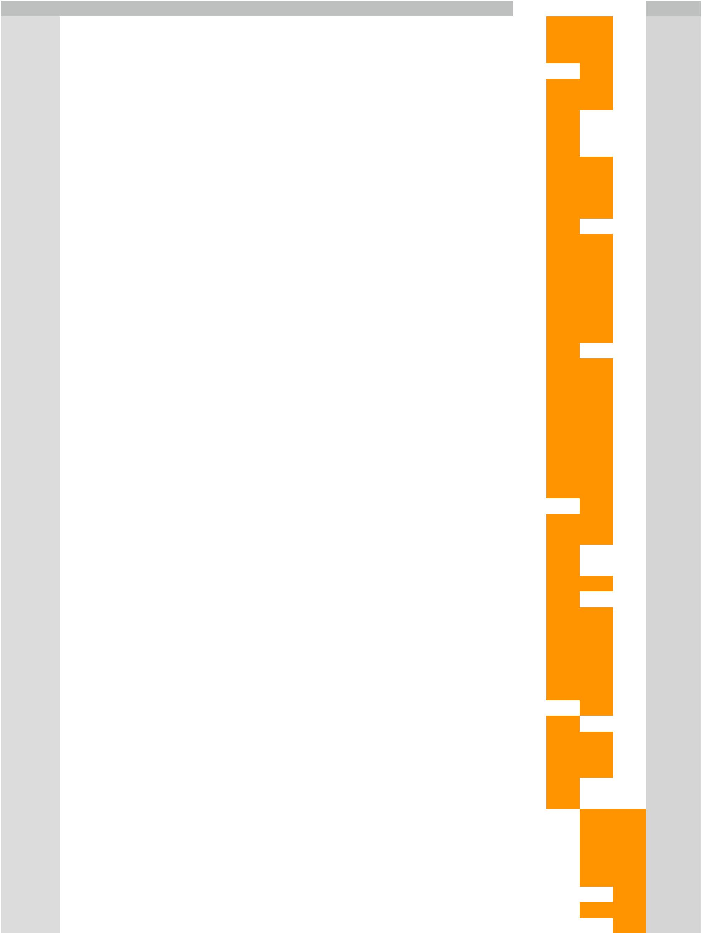

Material Code | Material Description | Monthly Demand | Glass Type | Weight (g) | Colour | Deficit | Vendor 1 | Vendor 2 | Vendor 3 | Vendor 4 | Optimal Cost
FGB052 | TFG SMOKY BLACK 70CL BTL 2015 | 24150.0 | Standard | 622 | Feeder | 0 | 0 | 11134 | 13016 | 0 | £ | 10,758.51
FGB055 | SMOKY BLACK 1L TINTED BTL 15 | 12496.0 | Standard | 728 | Feeder | 0 | 0 | 1363 | 11133 | 0 | £ | 6,317.33
FGB051 | MEL GLD12Y BLND/GLDRES AG3026 1L RND BT | 9240.0 | Standard | 728 | Feeder | 0 | 0 | 2107 | 7133 | 0 | £ | 4,720.79
FGB050 | GROUSE MELLOW GOLD12Y AG3018 70CL BTL 15 | 9900.0 | Standard | 622 | Feeder | 0 | 0 | 0 | 9900 | 0 | £ | 4,234.62
SWB035 | MAC.AG3118 12-17Y 70CL RND W/F CM BTL 17 | 378233.3 | Standard | 770 | Flint | 0 | 0 | 361212 | 17022 | 0 | £ | 122,262.18
SWB036 | MAC.AG3253 12-17Y 75CL RND W/F CM BTL17 | 182408.3 | Standard | 645 | Flint | 0 | 0 | 155594 | 26815 | 0 | £ | 56,231.47
SWB001 | MACALLAN AG2272 70CL RND W/F C.MOUTH | 196933.3 | Standard | 630 | Flint | 0 | 0 | 196934 | 0 | 0 | £ | 48,901.04
FGB045 | GROUSE 1.75L RND ROMAN BTL 2015 | 58455.0 | Standard | 1300 | Flint | 0 | 0 | 58455 | 0 | 0 | £ | 29,951.73
SWB037 | MAC AG3252 1L RND W/F CM BTL 2017 | 72380.0 | Standard | 800 | Flint | 0 | 0 | 72380 | 0 | 0 | £ | 22,822.61
SWB002 | MAC 75CL RND W/F C.MOUTH (2273) | 112583.3 | Standard | 506 | Flint | 0 | 0 | 78583 | 34001 | 0 | £ | 32,260.26
FGB059 | TFG 5CL RND BTL 2017 | 283352.0 | Standard | 81 | Flint | 0 | 0 | 171427 | 111925 | 0 | £ | 14,213.92
CGB060 | G/ROTHES2920/3137 70CL TORQ BTL(EX BBR) | 47855.5 | Standard | 700 | Flint | 0 | 0 | 24406 | 23450 | 0 | £ | 22,560.30
ESB002 | SNOW LEOPARD VODKA 70CL 40% BOTTLE EU13 | 9643.3 | Standard | 770 | Flint | 0 | 0 | 5458 | 4186 | 0 | £ | 4,764.15
FGB065 | NAKED GROUSE 700ML BOTTLE 2018 | 31335.4 | Standard | 480 | Flint | 0 | 0 | 31336 | 0 | 0 | £ | 5,928.46
SWB003 | MACALLAN 2286 1L RND W/F C.MOUTH | 25725.0 | Standard | 710 | Flint | 0 | 0 | 13582 | 12143 | 0 | £ | 12,113.34
CGB061 | G/ROTHES 2921/3137 75CLTORQ BTL(EXC BBR) | 18936.5 | Standard | 575 | Flint | 0 | 0 | 18709 | 228 | 0 | £ | 4,366.49
SWB045 | MAC.5CL RND W/F CM BTL (3360/3331) 2018 | 28600.0 | Standard | 80 | Flint | 0 | 0 | 27284 | 1316 | 0 | £ | 961.82
FGB044 | GROUSE 4.5L RND ROMAN BTL 2015 | 2594.7 | Standard | 2200 | Flint | 0 | 0 | 2545 | 50 | 0 | £ | 2,312.88
SWB019 | MAC(ALLIED)2615 50CL BTL W/F C/M | 10920.0 | Standard | 480 | Flint | 0 | 0 | 6835 | 4085 | 0 | £ | 3,183.63
ZWB024 | AR8171 W/F 1.5L LIGHTWEIGHT BTL ROPP | 17199.0 | Standard | 600 | Flint | 0 | 0 | 16872 | 327 | 0 | £ | 4,179.18
CGB062 | G/ROTHES 3117-3137 1L TORQ BTL(EXC BBR) | 6431.3 | Standard | 695 | Flint | 0 | 0 | 4669 | 1763 | 0 | £ | 2,460.35
ZWB032 | GEN.TRADE AG2650 500ML W/F BOTTLE | 11880.0 | Standard | 250 | Flint | 0 | 0 | 11880 | 0 | 0 | £ | 1,170.61
SWB018 | MACALLAN AG2574 1.75L BOTTLE W/F C/M | 2349.0 | Standard | 1060 | Flint | 0 | 0 | 1249 | 1100 | 0 | £ | 1,646.03
SWB043 | MAC.1.75L W/F CM BTL (AG 3275/3253) 2017 | 1875.0 | Standard | 1250 | Flint | 0 | 0 | 1003 | 872 | 0 | £ | 1,545.09
FGB060 | NAKED GROUSE AG3251 75CL C/M BOTTLE | 4225.0 | Standard | 500 | Flint | 0 | 0 | 2319 | 1906 | 0 | £ | 1,375.85
CGB063 | G/ROTHES AG2305 10CL BTL (EXC BBR) | 6562.5 | Standard | 134 | Flint | 0 | 0 | 3825 | 2738 | 0 | £ | 555.76
FGB058 | TFG SMOKY BLACK 75CL BTL 2015 | 3750.0 | Standard | 505 | Flint | 0 | 0 | 3517 | 233 | 0 | £ | 813.48
FGB066 | NAKED GROUSE FOOT 75CL BOTTLE AG3251 18 | 2887.1 | Standard | 500 | Flint | 0 | 0 | 2173 | 715 | 0 | £ | 772.93
FGB061 | NAKED GROUSE 1L BTL PE7681 | 804.3 | Standard | 630 | Flint | 0 | 0 | 695 | 110 | 0 | £ | 239.39
MWB040 | AG3110 MAC F&R 70CL WF RND CM BTL GX 17 | 780.0 | Standard | 510 | Flint | 0 | 0 | 521 | 259 | 0 | £ | 232.08
MWB041 | AG3109 MAC F&R 75CL WF RND CM BTL GX 17 | 67.7 | Standard | 520 | Flint | 0 | 0 | 56 | 12 | 0 | £ | 17.49
CGY378 | G/ROTHES 70CL BTL ASSY(CGB060)GLOSS BLK | 231.0 | Standard | 700 | Sprayed Bottle | 0 | 0 | 0 | 231 | 0 | £ | 421.92
FGB049 | GROUSE(140661/13679) 1L RND BTL 2015 | 544074.7 | Standard | 550 | Flint | 0 | 0 | 380852 | 163223 | 0 | £ | 169,116.08
FGB043 | TFG 70CL(140572/13670)RND ROMAN BTL 2015 | 419594.7 | Standard | 435 | Flint | 0 | 0 | 363788 | 55807 | 0 | £ | 85,778.60
ZWB027 | AR8660/SE667(130439)GENERIC 1L L/WT W/F | 50587.3 | Standard | 450 | Flint | 0 | 0 | 50588 | 0 | 0 | £ | 8,972.57
ZWB024 | AR8171 W/F 1.5L LIGHTWEIGHT BTL ROPP | 8994.3 | Standard | 600 | Flint | 0 | 0 | 8995 | 0 | 0 | £ | 2,127.20
FGB063A | TFG 70CL (140572/13670) RND ROMAN BTL L4 | 8720.0 | Standard | 435 | Flint | 0 | 0 | 6993 | 1727 | 0 | £ | 1,923.29
CSB253 | C/S(9417)1.75L GRN BTL(HANDLE)11 | 33637.7 | Standard | 1300 | Green | 0 | 0 | 33638 | 0 | 0 | £ | 24,060.49
CSB250 | 110167/AR9411 70CL STL/INB GRN11(170968) | 156080.0 | Standard | 394 | Green | 0 | 0 | 155611 | 469 | 0 | £ | 33,842.25
ZWB029 | AR9368/5218/8509GEN L/W 70CL W/F(140712) | 61279.0 | Standard | 298 | Multi | 0 | 0 | 42282 | 18997 | 0 | £ | 9,410.08
HUB001 | H/P VALKYRIE 70/75CL BOTTLE 17 | 33150.0 | Standard | 595 | Amber | 0 | 0 | 11868 | 21282 | 0 | £ | 19,883.02
CCB002 | C/S C/BAND 75CL 120073 BLKBTL CM(960648) | 1650.0 | Standard | 500 | Amber | 0 | 0 | 571 | 1079 | 0 | £ | 831.41
CCB001 | C/S C/BAND 120072 70CL BLKBTL CM(960647) | 1122.0 | Standard | 625 | Amber | 0 | 0 | 521 | 601 | 0 | £ | 708.64
HUB002 | H/P VALKYRIE 70CL SF218 BOTTLE | 510.0 | Standard | 720 | Amber | 0 | 0 | 5 | 505 | 0 | £ | 367.16
CCB003 | C/S PROHIBITION 120579 1L BTL | 213.3 | Standard | 750 | Amber | 0 | 0 | 0 | 214 | 0 | £ | 160.44
CSB252 | C/S 110212(171010) 1L STEL BTL 2011 | 118833.3 | Standard | 500 | Green | 0 | 0 | 118834 | 0 | 0 | £ | 32,692.01
CSB251 | C/S 110211(171009) 75CL STEL/INB BTL 11 | 22911.7 | Standard | 394 | Green | 0 | 0 | 14388 | 8524 | 0 | £ | 5,087.07
ZWB035 | GENERIC(1424)500ML GRN BTL(INVERTED TRAY | 6424.0 | Standard | 400 | Green | 0 | 0 | 5730 | 694 | 0 | £ | 1,423.76
ZWB001 | AB319 50ML GREEN ROUND.20MM(170621) | 9500.0 | Standard | 80 | Green | 0 | 0 | 4949 | 4551 | 0 | £ | 431.18
CSB257 | C/S 1139 37.5CL FLASK 2011(171108) | 966.7 | Standard | 406 | Green | 0 | 0 | 967 | 0 | 0 | £ | 216.01
CSB255 | C/S 110240(171217) 35CL NR ROUND BTL 11 | 277.5 | Standard | 300 | Green | 0 | 0 | 278 | 0 | 0 | £ | 45.89
FGB049 | GROUSE(140661/13679) 1L RND BTL 2015 | 735914.7 | Standard | 350 | White Flint | 0 | 0 | 0 | 34589 | 701326 | £ | 195,163.64
FGB043 | TFG 70CL(140572/13670)RND ROMAN BTL 2015 | 364577.0 | Standard | 435 | White Flint | 0 | 0 | 0 | 174633 | 189944 | £ | 123,530.03
HWB022 | H/P 70CL CORE BTL 2017 | 115560.0 | Standard | 732 | White Flint | 0 | 0 | 0 | 53389 | 62171 | £ | 65,818.35
GWB020 | 6470/SD25 200ML FLASK W/F 30MM (130201) | 217056.0 | Standard | 269 | White Flint | 0 | 0 | 0 | 91164 | 125892 | £ | 45,310.60
ZWB003 | SD1150/AG746 35CL FLK W/F 30MM(130252) | 197750.0 | Standard | 80 | White Flint | 0 | 0 | 0 | 26301 | 171449 | £ | 12,053.78
FGB048 | GROUSE 140660 75CL RND BTL 2015 | 123878.3 | Standard | 465 | White Flint | 0 | 0 | 0 | 0 | 123879 | £ | 43,514.01
FGB047 | GROUSE 1.13L (140784) RND BTL 2015 | 21792.0 | Standard | 650 | White Flint | 0 | 0 | 0 | 7475 | 14317 | £ | 10,938.70
HWB021 | H/PARK 75CL 4346(177248)EST CM BTL 2017 | 32400.0 | Standard | 607 | White Flint | 0 | 0 | 0 | 0 | 32400 | £ | 14,856.35

Page 12

Appendix 2: The optimal solution for 10 weeks Lead Time and the cullt % bettween 0.2 to 0.4(con’t)


GAB014 | SD579/6315 10CL FLASK W/F 30MM(125351) | 53200.0 | Standard | 190 | White Flint | 0 | 0 | 0 | 0 | 53200 | £ | 7,635.61
FGB040 | TFG 35CL RND ROMAN BTL 2015 | 28915.5 | Standard | 300 | White Flint | 0 | 0 | 0 | 4078 | 24838 | £ | 6,613.04
FGB046 | GROUSE 1.5L RND ROMAN BTL 2015 | 25127.7 | Standard | 800 | White Flint | 0 | 0 | 0 | 4273 | 20855 | £ | 15,353.25
HWB024 | H/PARK 1L BTL 18 | 13240.0 | Standard | 700 | White Flint | 0 | 0 | 0 | 3112 | 10128 | £ | 7,108.03
FGB041 | TFG 50CL RND ROMAN BTLE 2015 | 17340.0 | Standard | 400 | White Flint | 0 | 0 | 0 | 0 | 17340 | £ | 5,239.47
SWB042 | MAC50CL RNDW/F CM BTL OI F3170683/178335 | 10296.0 | Standard | 550 | White Flint | 0 | 0 | 0 | 845 | 9451 | £ | 4,300.51
TFB449 | GLEN CRINAN 70CL BOTTLE 2015 | 11113.3 | Standard | 525 | White Flint | 0 | 0 | 0 | 2713 | 8401 | £ | 4,477.60
HWB023 | H/P 35CL BOTTLE 17 | 5830.0 | Standard | 400 | White Flint | 0 | 0 | 0 | 2076 | 3754 | £ | 1,802.37
TFB448 | GLEN CRINAN 1L BOTTLE 2015 | 6009.7 | Standard | 625 | White Flint | 0 | 0 | 0 | 1888 | 4122 | £ | 2,895.42
HPB002 | H/P 5CL OVAL W/F (125454) | 18890.8 | Standard | 80 | White Flint | 0 | 0 | 0 | 2457 | 16434 | £ | 1,151.28
SWB009 | MAC.5CL TALL RND W/F CM 017278(125626) | 12480.0 | Standard | 80 | White Flint | 0 | 0 | 0 | 312 | 12168 | £ | 755.42
HPB001 | H/PARK SF096 1L OVAL C/M W/F(170935) | 2669.3 | Standard | 700 | White Flint | 0 | 0 | 0 | 0 | 2670 | £ | 1,411.85
SWB041 | MAC37.5CL RNDW/FCMBTL OI F3170682/178334 | 3293.3 | Standard | 325 | White Flint | 0 | 0 | 0 | 0 | 3294 | £ | 808.70
FGB063A | TFG 70CL (140572/13670) RND ROMAN BTL L4 | 7999.7 | Standard | 435 | White Flint | 0 | 0 | 0 | 0 | 8000 | £ | 2,628.80
HWB001 | H/P SF094 70CL BOTTLE C/M (170932) | 3414.2 | Standard | 650 | White Flint | 0 | 0 | 0 | 0 | 3415 | £ | 1,676.80
ZWB027 | AR8660/SE667(130439)GENERIC 1L L/WT W/F | 4224.0 | Standard | 450 | White Flint | 0 | 0 | 0 | 609 | 3615 | £ | 1,449.33
TFB447 | GLEN CRINAN 50CL BTL 15 (150241) | 3021.7 | Standard | 400 | White Flint | 0 | 0 | 0 | 128 | 2894 | £ | 915.64
GWB006 | SD27 500ML FLASK W/F 30MM (130202) | 2621.7 | Standard | 470 | White Flint | 0 | 0 | 0 | 711 | 1911 | £ | 947.32
FGB064A | GROUSE 140660 75CL RND BTL 2015 LINE 4 | 4194.0 | Standard | 465 | White Flint | 0 | 0 | 0 | 1783 | 2411 | £ | 1,513.90
SWB040 | MAC35CL RNDW/F CM BTL OI F3170681/178333 | 1733.3 | Standard | 390 | White Flint | 0 | 0 | 0 | 320 | 1414 | £ | 516.98
HWB002 | H/P 75CL SF095 OVAL W/F(170933) | 1326.3 | Standard | 550 | White Flint | 0 | 0 | 0 | 163 | 1164 | £ | 555.73
HWB025 | H/P 70/75CL CORE BTL BLACK 2018 | 900.0 | Standard | 732 | White Flint | 0 | 0 | 0 | 378 | 522 | £ | 511.25
ZWB030 | G/TRADE 1403(130686)1.13L RNDGRN 30MM 11 | 1056.0 | Standard | 650 | White Flint | 0 | 0 | 0 | 197 | 859 | £ | 524.80
FGB062A | GROUSE(140661/13679) 1L RND BTL 2015 L4 | 1701.3 | Standard | 350 | White Flint | 0 | 0 | 0 | 466 | 1236 | £ | 458.00
YRB013 | MAC.RARE (V4) 75CL (8840E) BOTTLE 2017 | 3651.7 | Premium | 1112 | Cosmetic Flint | 0 | 2019 | 1633 | 0 | 0 | £ | 11,023.05
BAB001 | BRUGAL 5CL W/F 20MM BOTTLE SF8858 | 44968.0 | Premium | 73 | Cosmetic Flint | 0 | 24687 | 20281 | 0 | 0 | £ | 8,913.28
WZY003 | OSCURO(V5)70CL DEC.BTL & COLLAR ASSY15 | 1011.2 | Premium | 1190 | Cosmetic Flint | 0 | 804 | 208 | 0 | 0 | £ | 3,200.51
YRB015 | MAC RARE CASK (V5) 70CL (8829G) BOTTLE | 1691.6 | Premium | 1256 | Cosmetic Flint | 0 | 1692 | 0 | 0 | 0 | £ | 5,545.25
YRB016 | MAC RARE CASK (V5) 75CL (8840F) BOTTLE | 910.0 | Premium | 1256 | Cosmetic Flint | 0 | 677 | 233 | 0 | 0 | £ | 3,051.10
YXB006 | MAC.REFLEXION(V5) 75CL DECORATED BTL 15 | 194.0 | Premium | 1190 | Cosmetic Flint | 0 | 193 | 1 | 0 | 0 | £ | 602.67
YXY005 | REFLEXION(V5)75CL DECOR.BTL &COL ASSY15 | 162.9 | Premium | 1190 | Cosmetic Flint | 0 | 163 | 0 | 0 | 0 | £ | 506.13
YXY004 | REFLEXION(V5)70CL DECOR.BTL &COL ASSY15 | 109.2 | Premium | 1190 | Cosmetic Flint | 0 | 56 | 54 | 0 | 0 | £ | 356.65
FGB067 | NAKED GROUSE 5CL FLASK BOTTLE STO 4944 | 2033.7 | Premium | 62 | Cosmetic Flint | 0 | 1370 | 664 | 0 | 0 | £ | 338.73
HAB001 | HIGHLAND PARK 40YO 70CL BTL (8574) | 45.8 | Premium | 810 | Cosmetic Flint | 0 | 42 | 4 | 0 | 0 | £ | 97.99
YRY022 | MAC RARE CASK 75CL SPRAYED BLK BTL | 2720.7 | Premium | 1112 | Decorated Bottle | 0 | 1920 | 0 | 801 | 0 | £ | 9,998.05
HWY023 | HIGHLAND PARK 5CL BLACK BOTTLE ASSY | 11083.1 | Premium | 73 | Decorated Bottle | 0 | 5674 | 0 | 5410 | 0 | £ | 2,706.66
YRY021 | MAC RARE CASK 70/75CL SPRAYED BLK BTL | 1850.1 | Premium | 1112 | Decorated Bottle | 0 | 1328 | 0 | 523 | 0 | £ | 6,796.19
YRB017 | MAC RARE CASK SPRYD 70/75CL BOTTLE (V2) | 560.0 | Premium | 1112 | Decorated Bottle | 0 | 323 | 0 | 237 | 0 | £ | 2,074.57
HSB007 | HP THE LIGHT 70CL BOTTLE GREEN 17 | 2453.8 | Premium | 730 | Feeder Green | 0 | 2454 | 0 | 0 | 0 | £ | 2,071.82
HSB005 | HP THE DARK 70CL BTL BLACK 17 | 1048.7 | Premium | 730 | Feeder Green | 0 | 1038 | 11 | 0 | 0 | £ | 886.47
HSB008 | HP THE LIGHT 75CL BOTTLE GREEN 17 | 1096.3 | Premium | 630 | Feeder Green | 0 | 950 | 147 | 0 | 0 | £ | 808.92
SUM |  |  |  |  |  |  | 45,390 | 2,512,217 | 985,373 | 1,635,474 | £ | 1,462,787.47

Page 13

